**Prak.Pemograman Berorientasi Web**

KELAS A

# “Tugas 04”



Nama

Maulana Ibrahim / 4522210090

Dosen :

Adi Wahyu Pribadi, S.Si., M.Kom

**PROGRAM STUDI TEKNIK INFORMATIKA UNIVERSITAS**

**PANCASILA**

**2022**

1. Masukkan beberapa Codingan :

A. Admin1.PHP

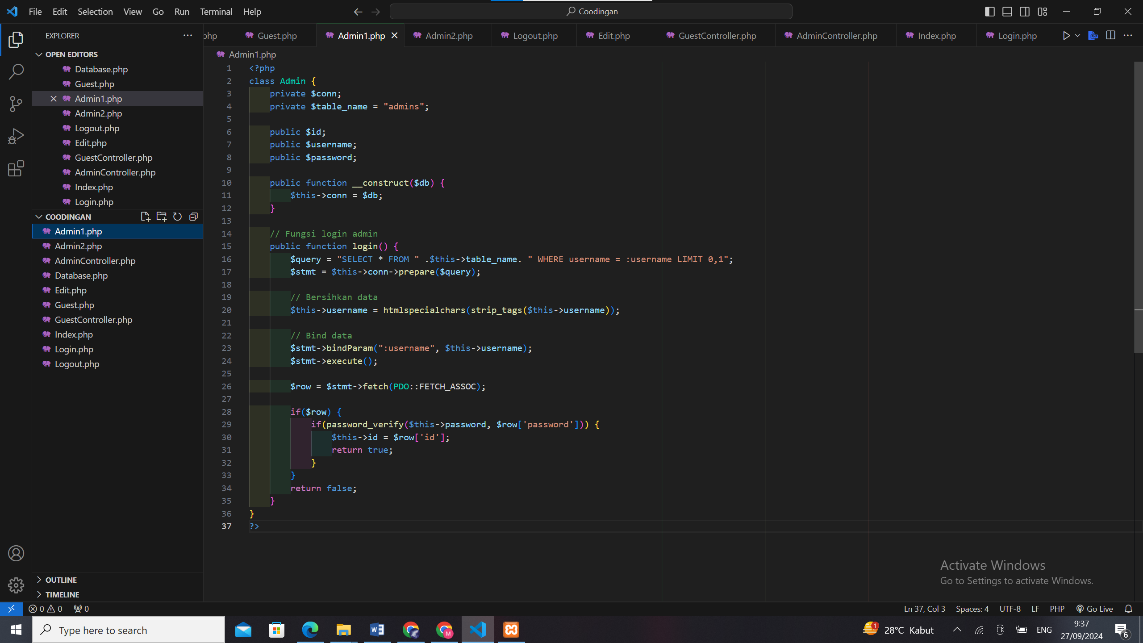

B. Admin2.PHP

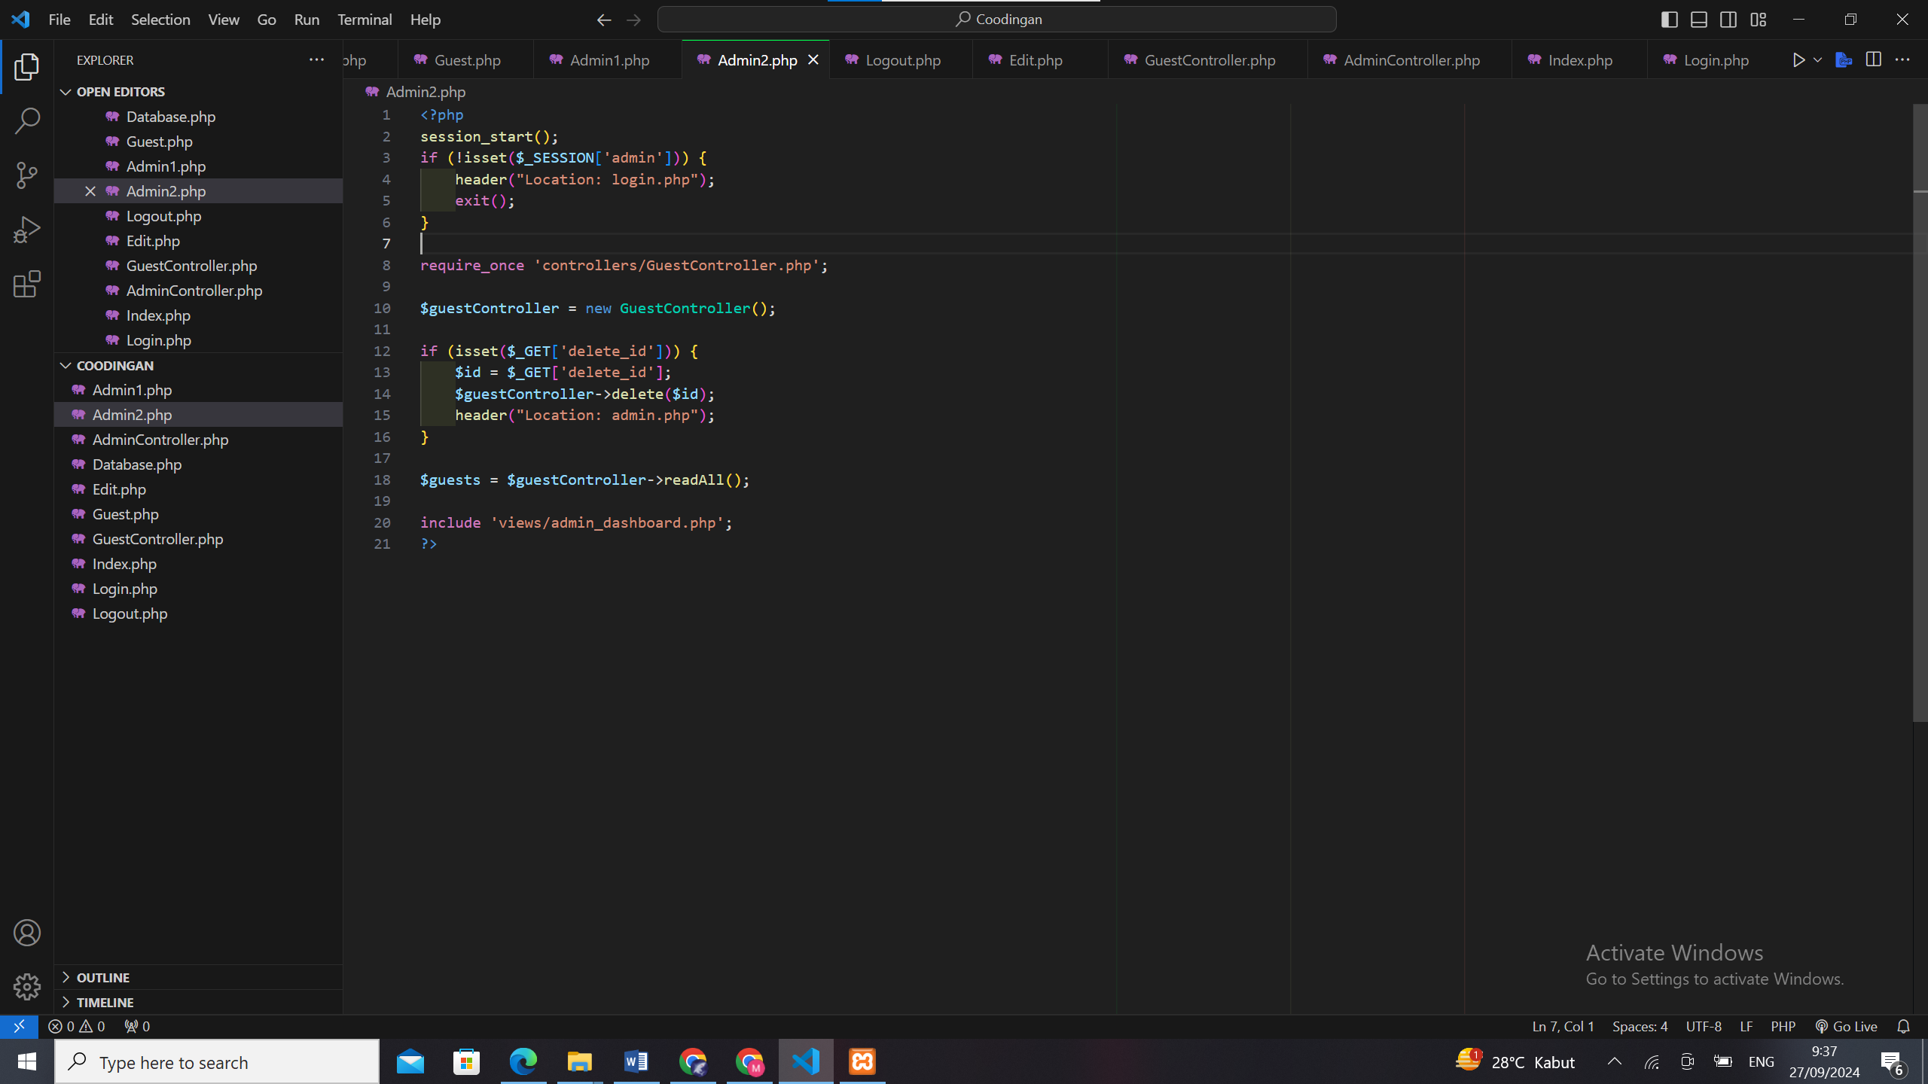

C. AdminController.PHP

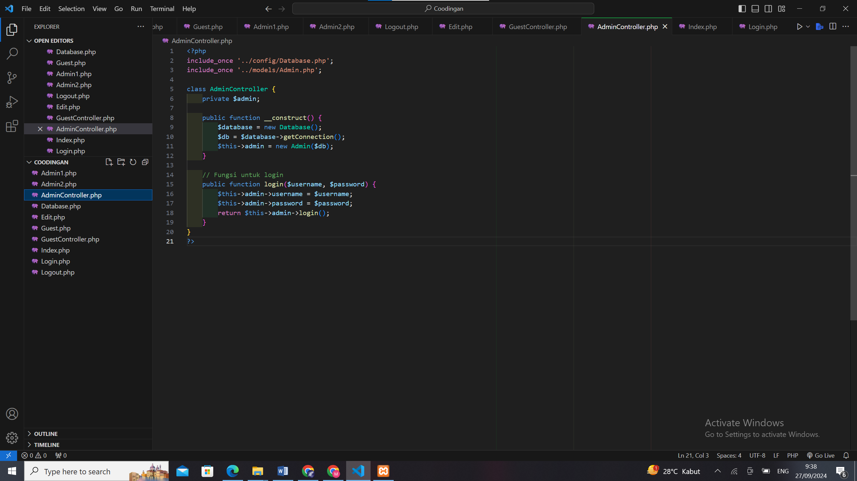

D. Database.PHP

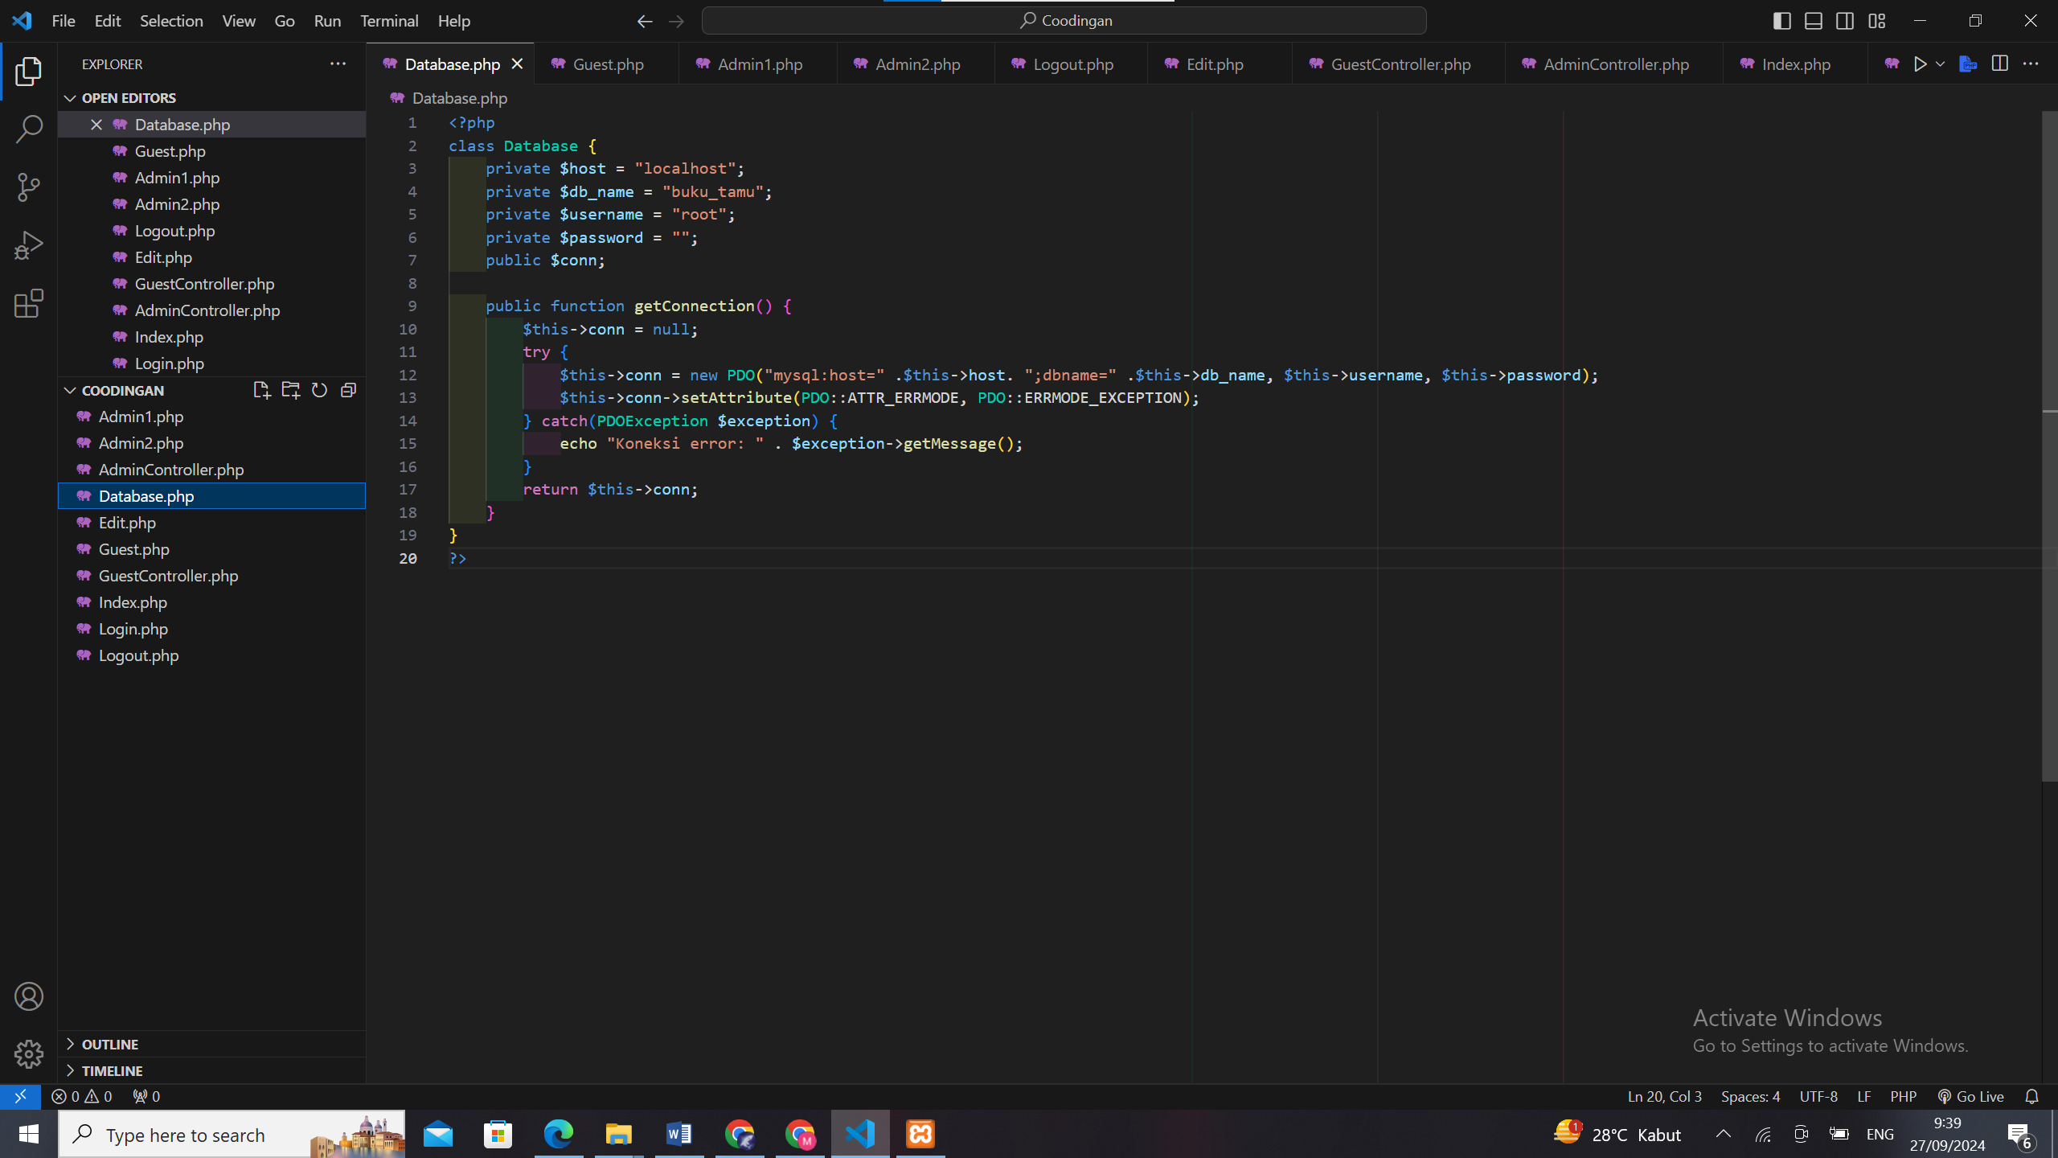

E. Edit.PHP

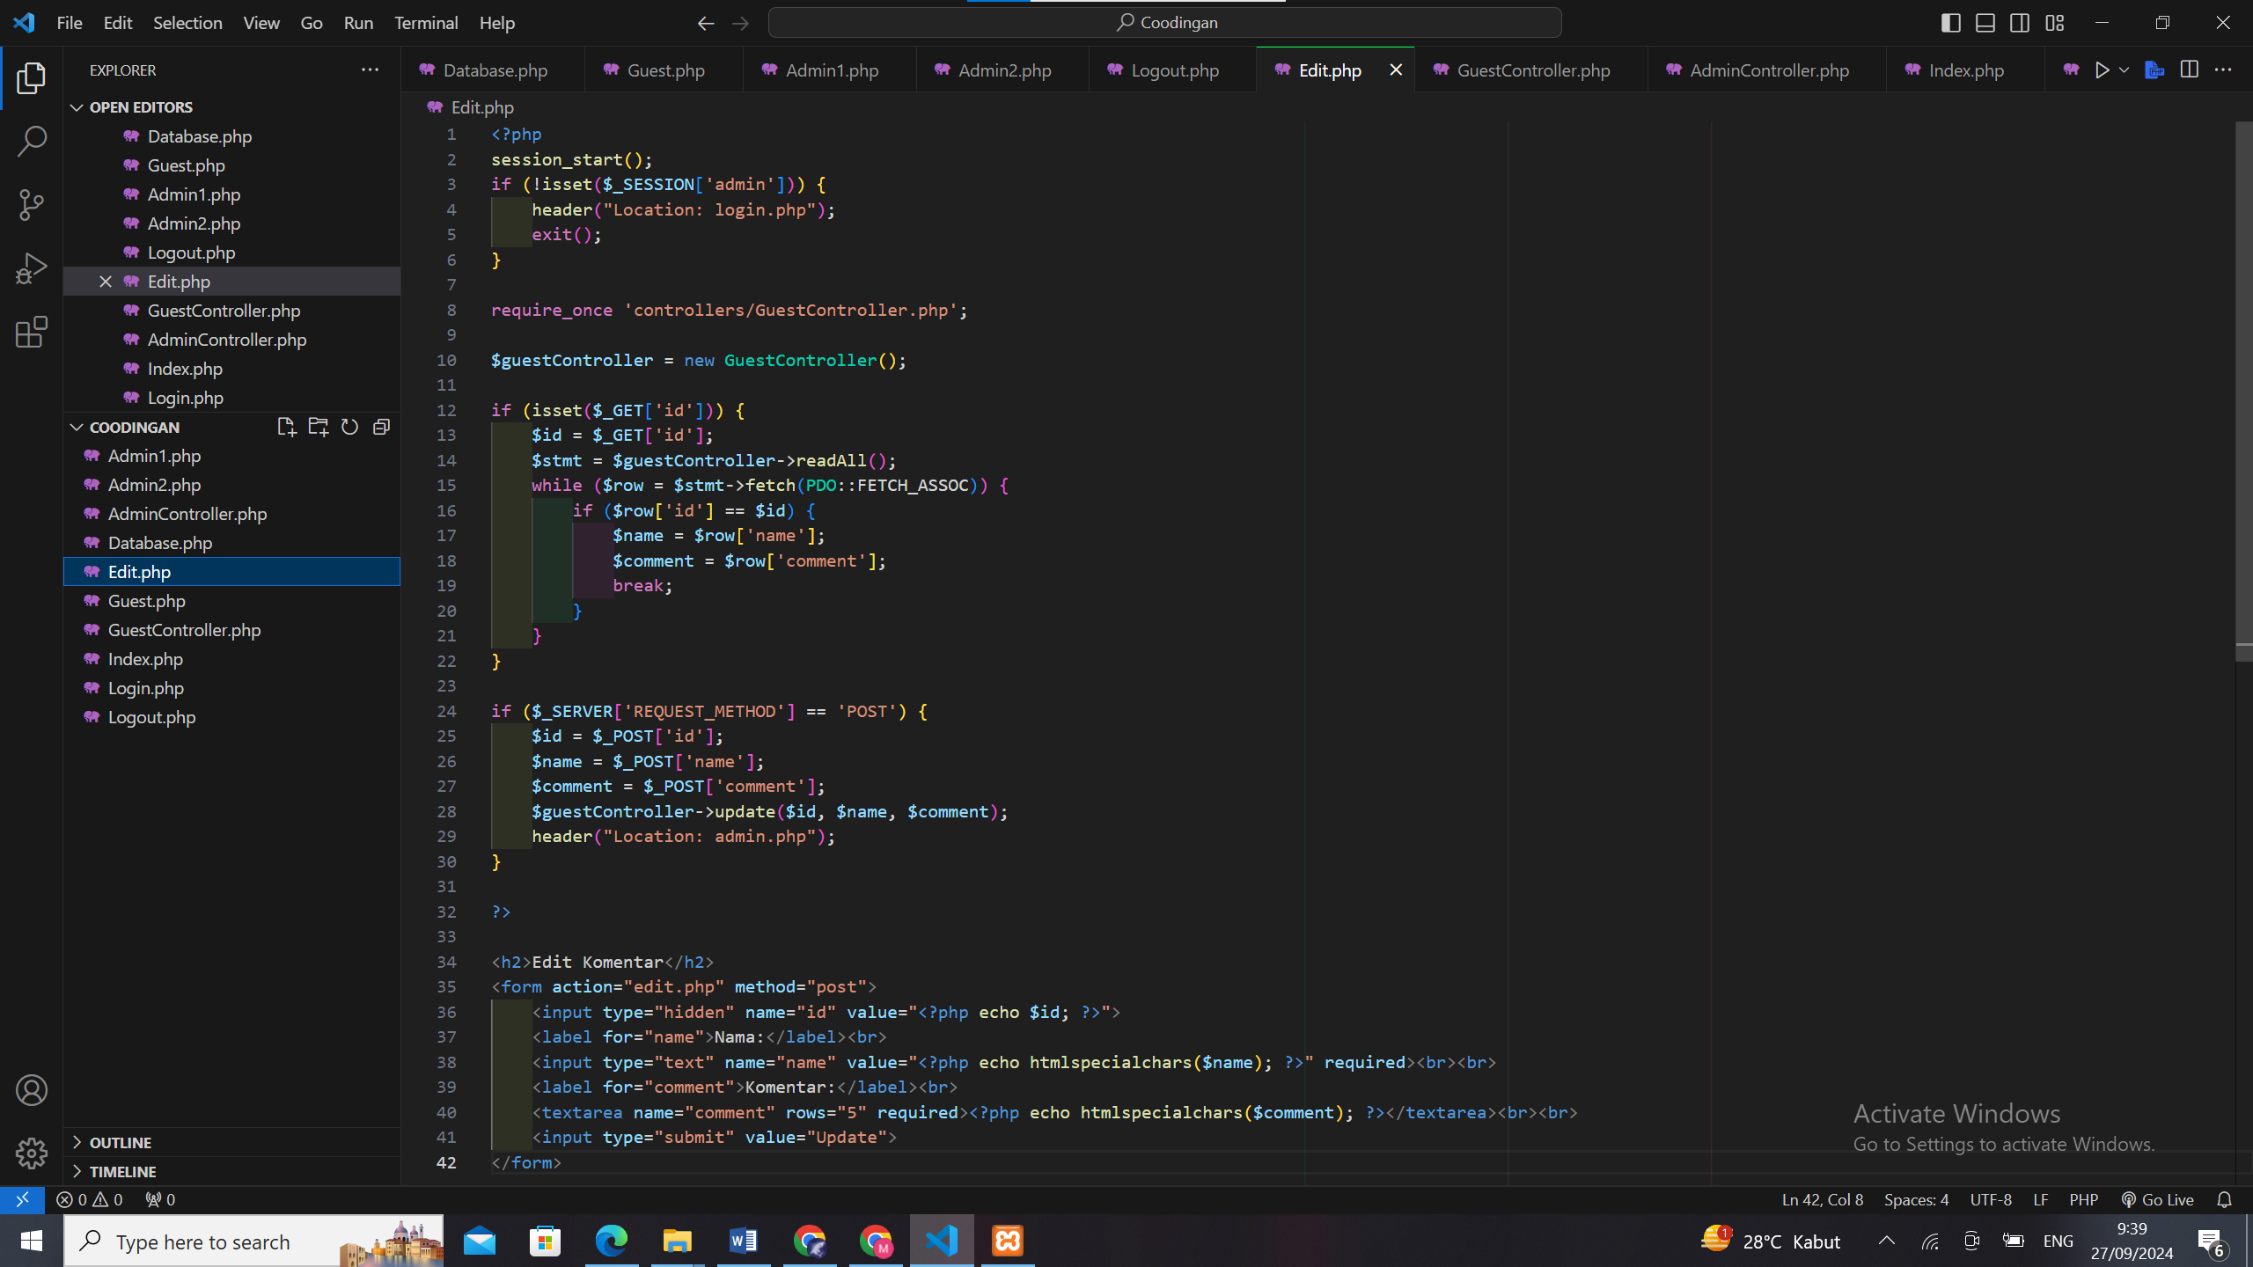

F. Guest.PHP

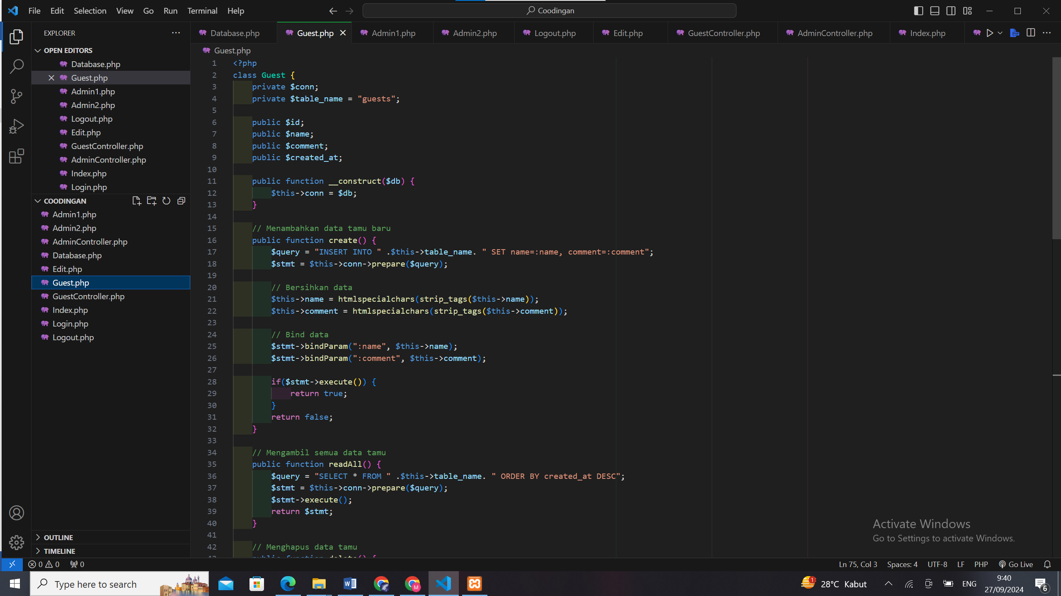

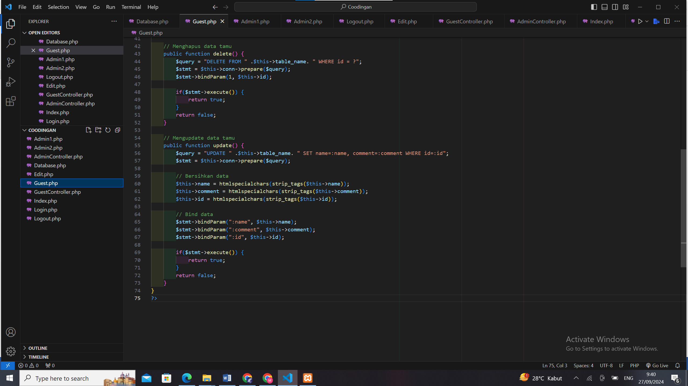

G. GuestController.PHP

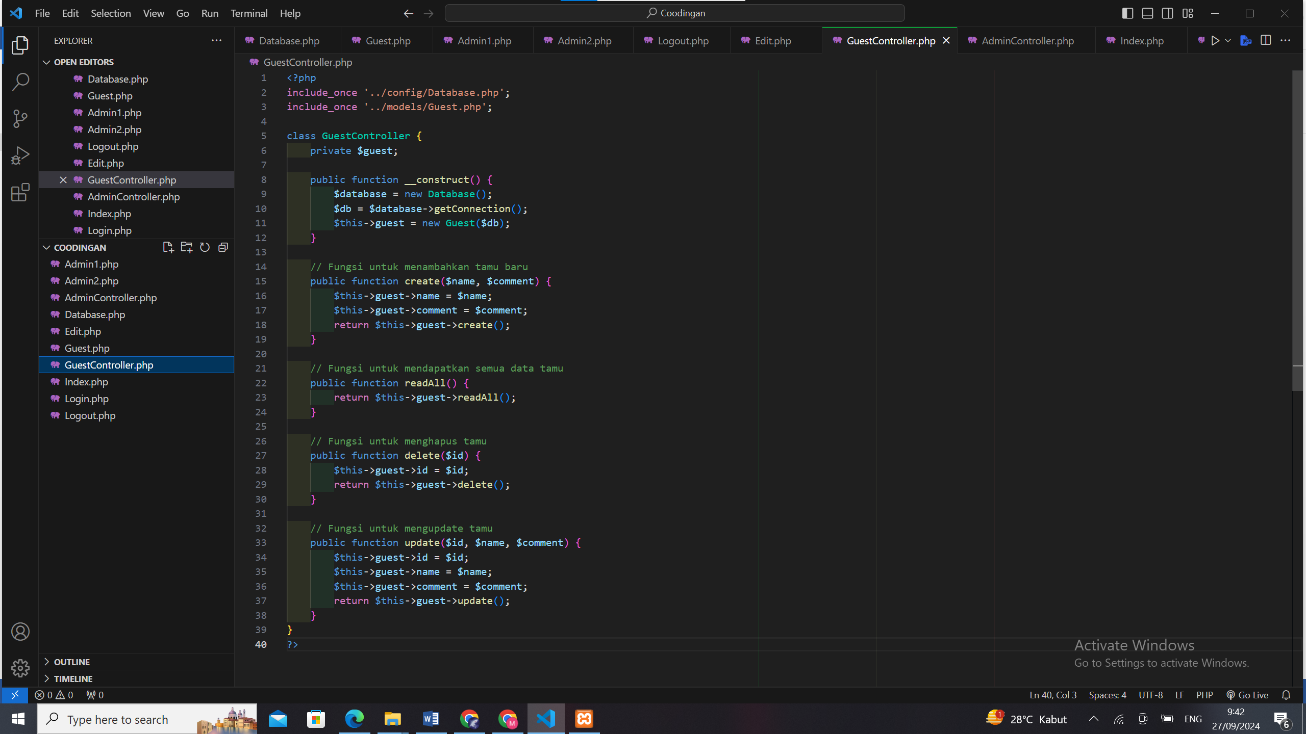

H. Index.PHP

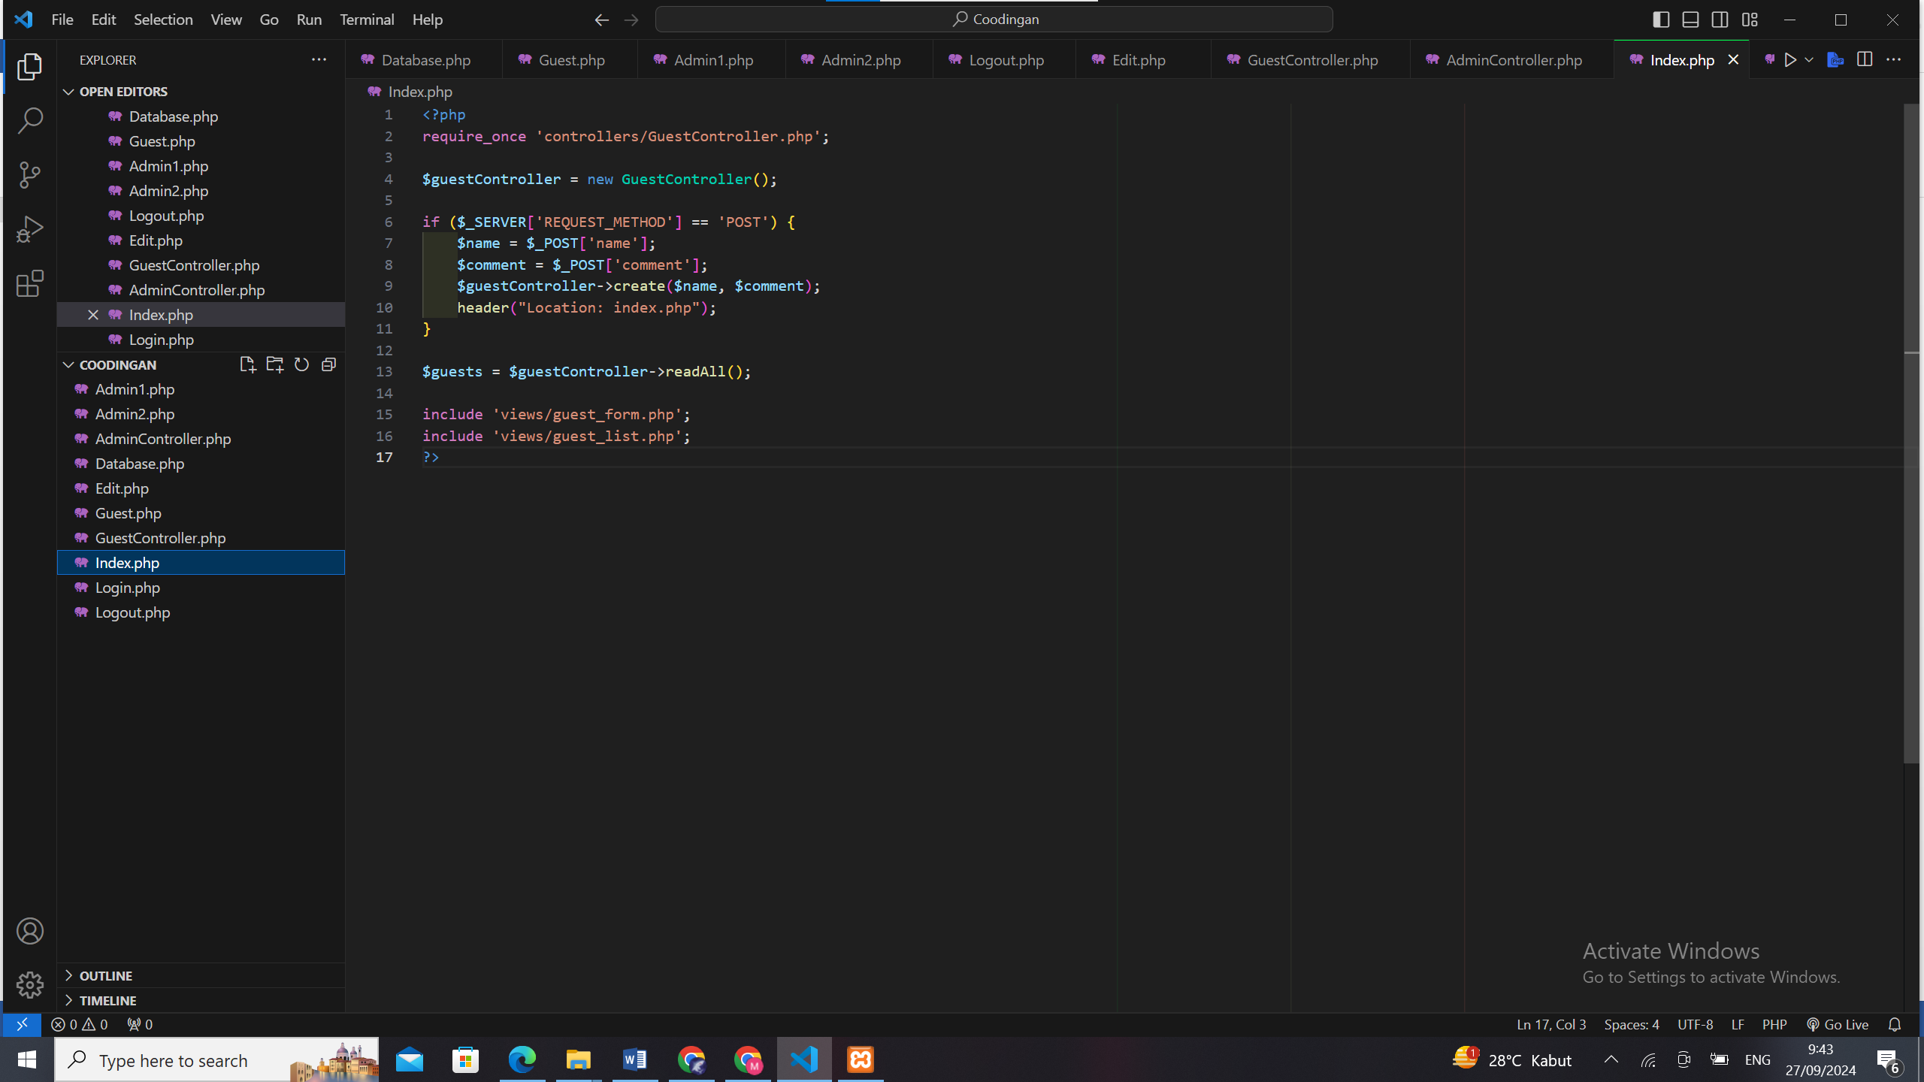

I. Login.PHP

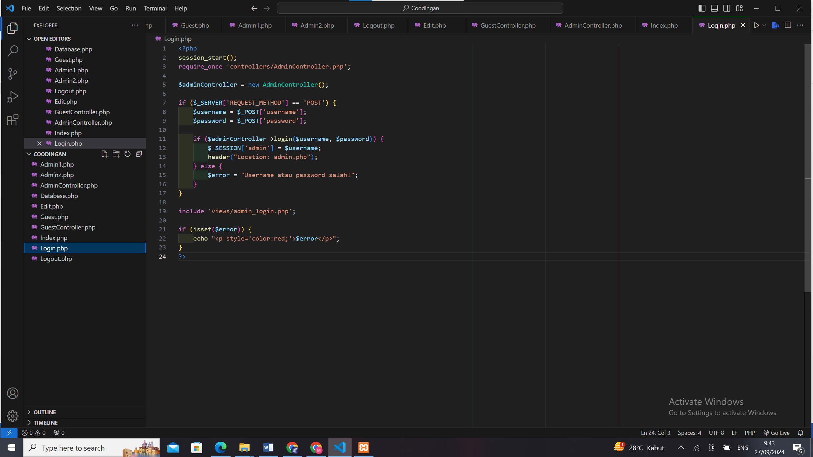

J. Logout.PHP

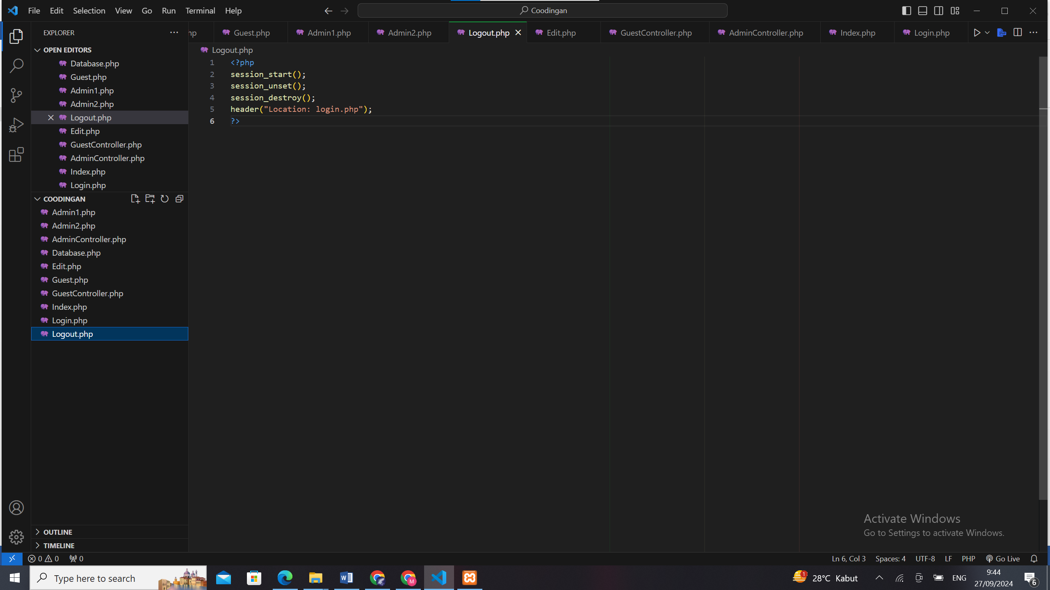

Hasil setelah di rapihkan

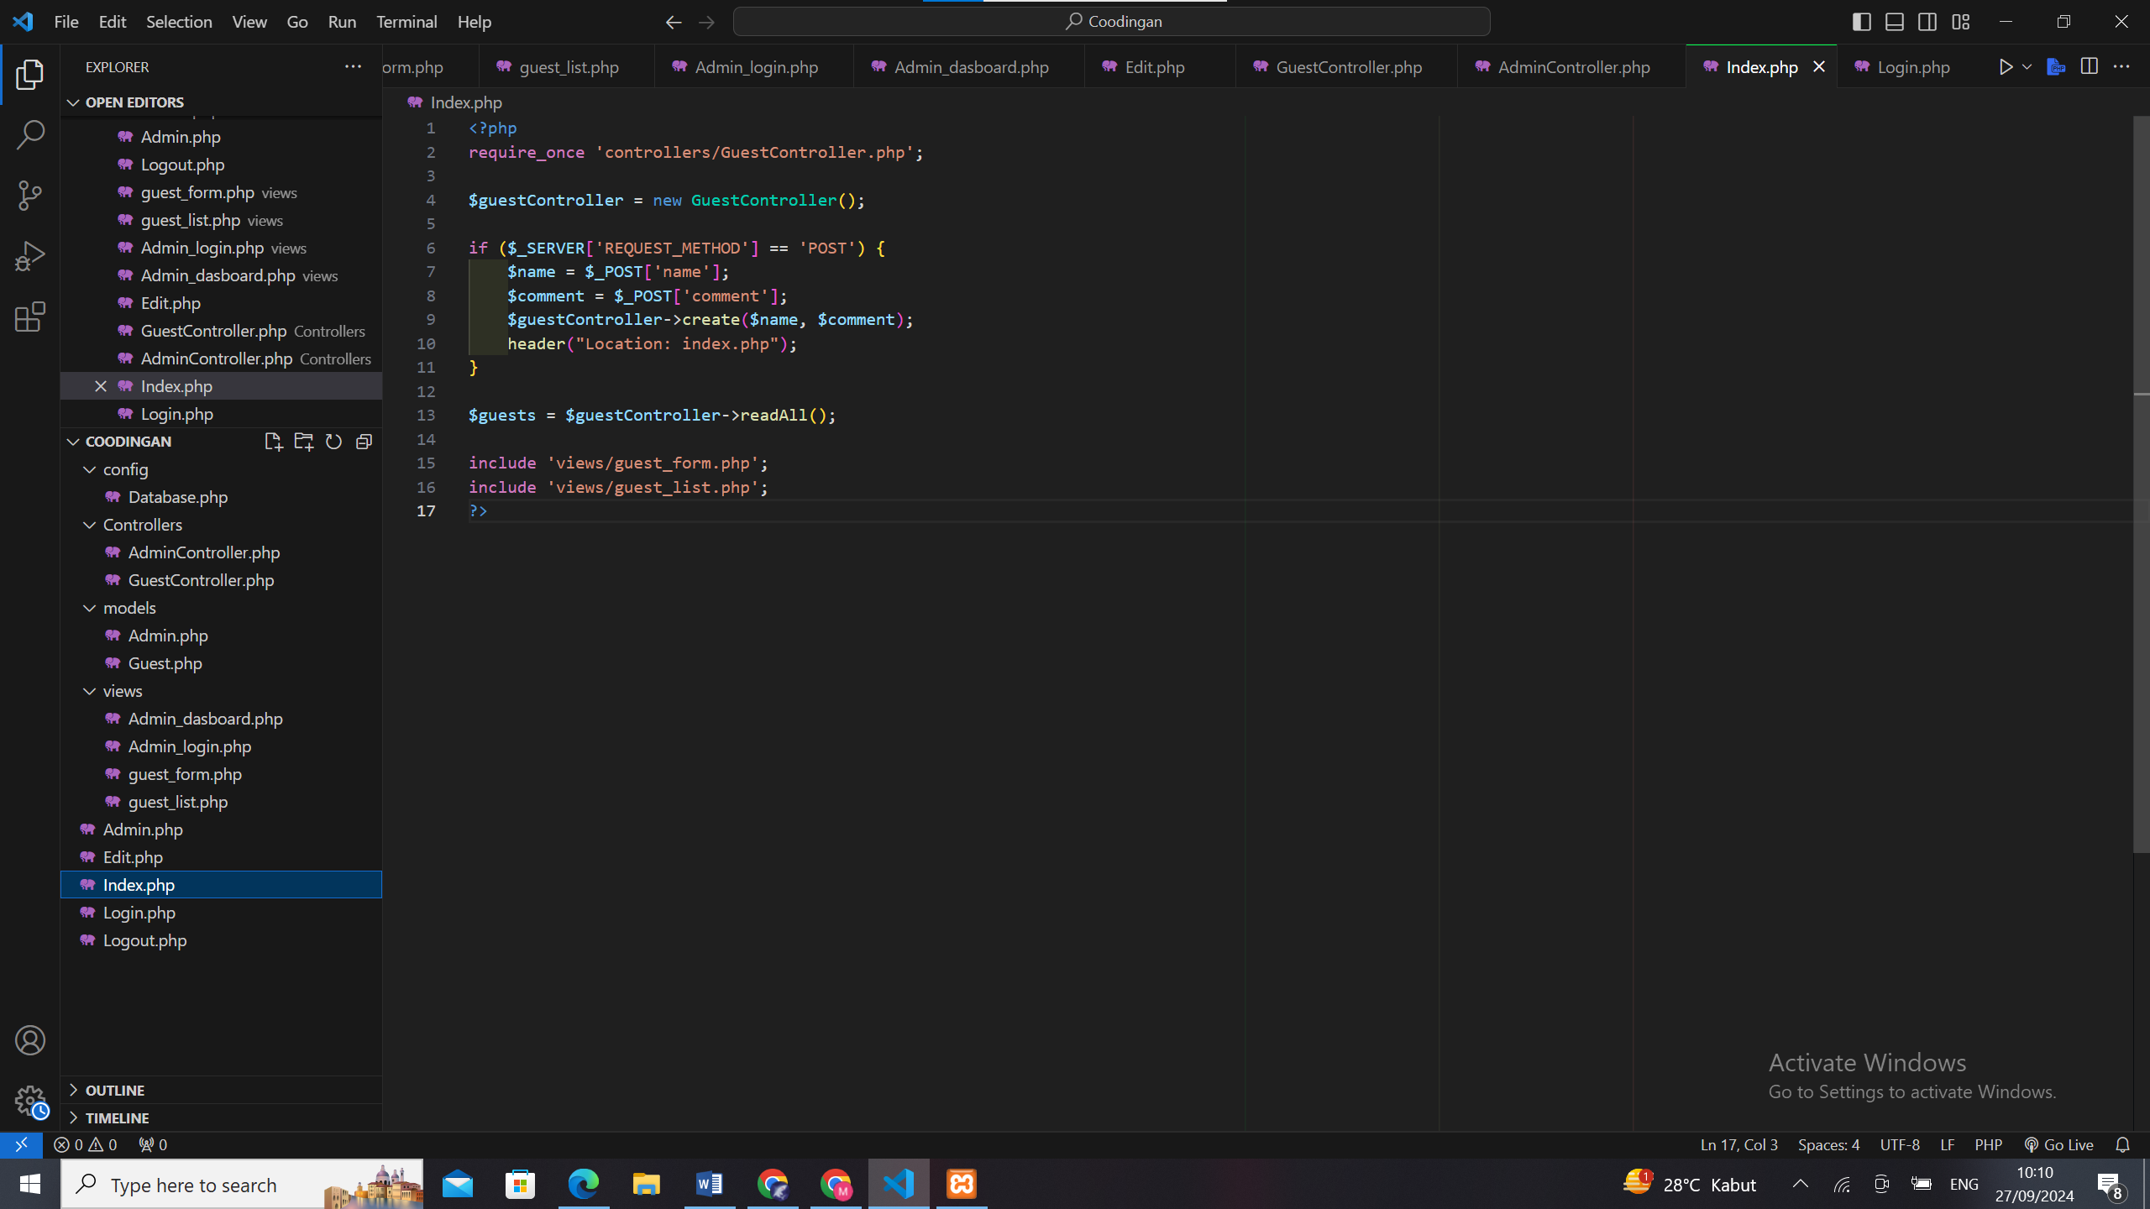

2. Create Database

A. **CREATE** **DATABASE** buku_tamu; 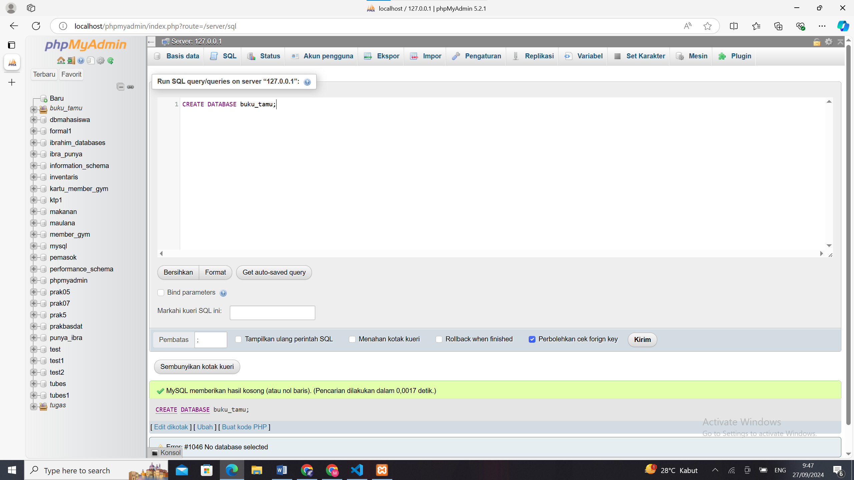

B. **USE** buku_tamu;

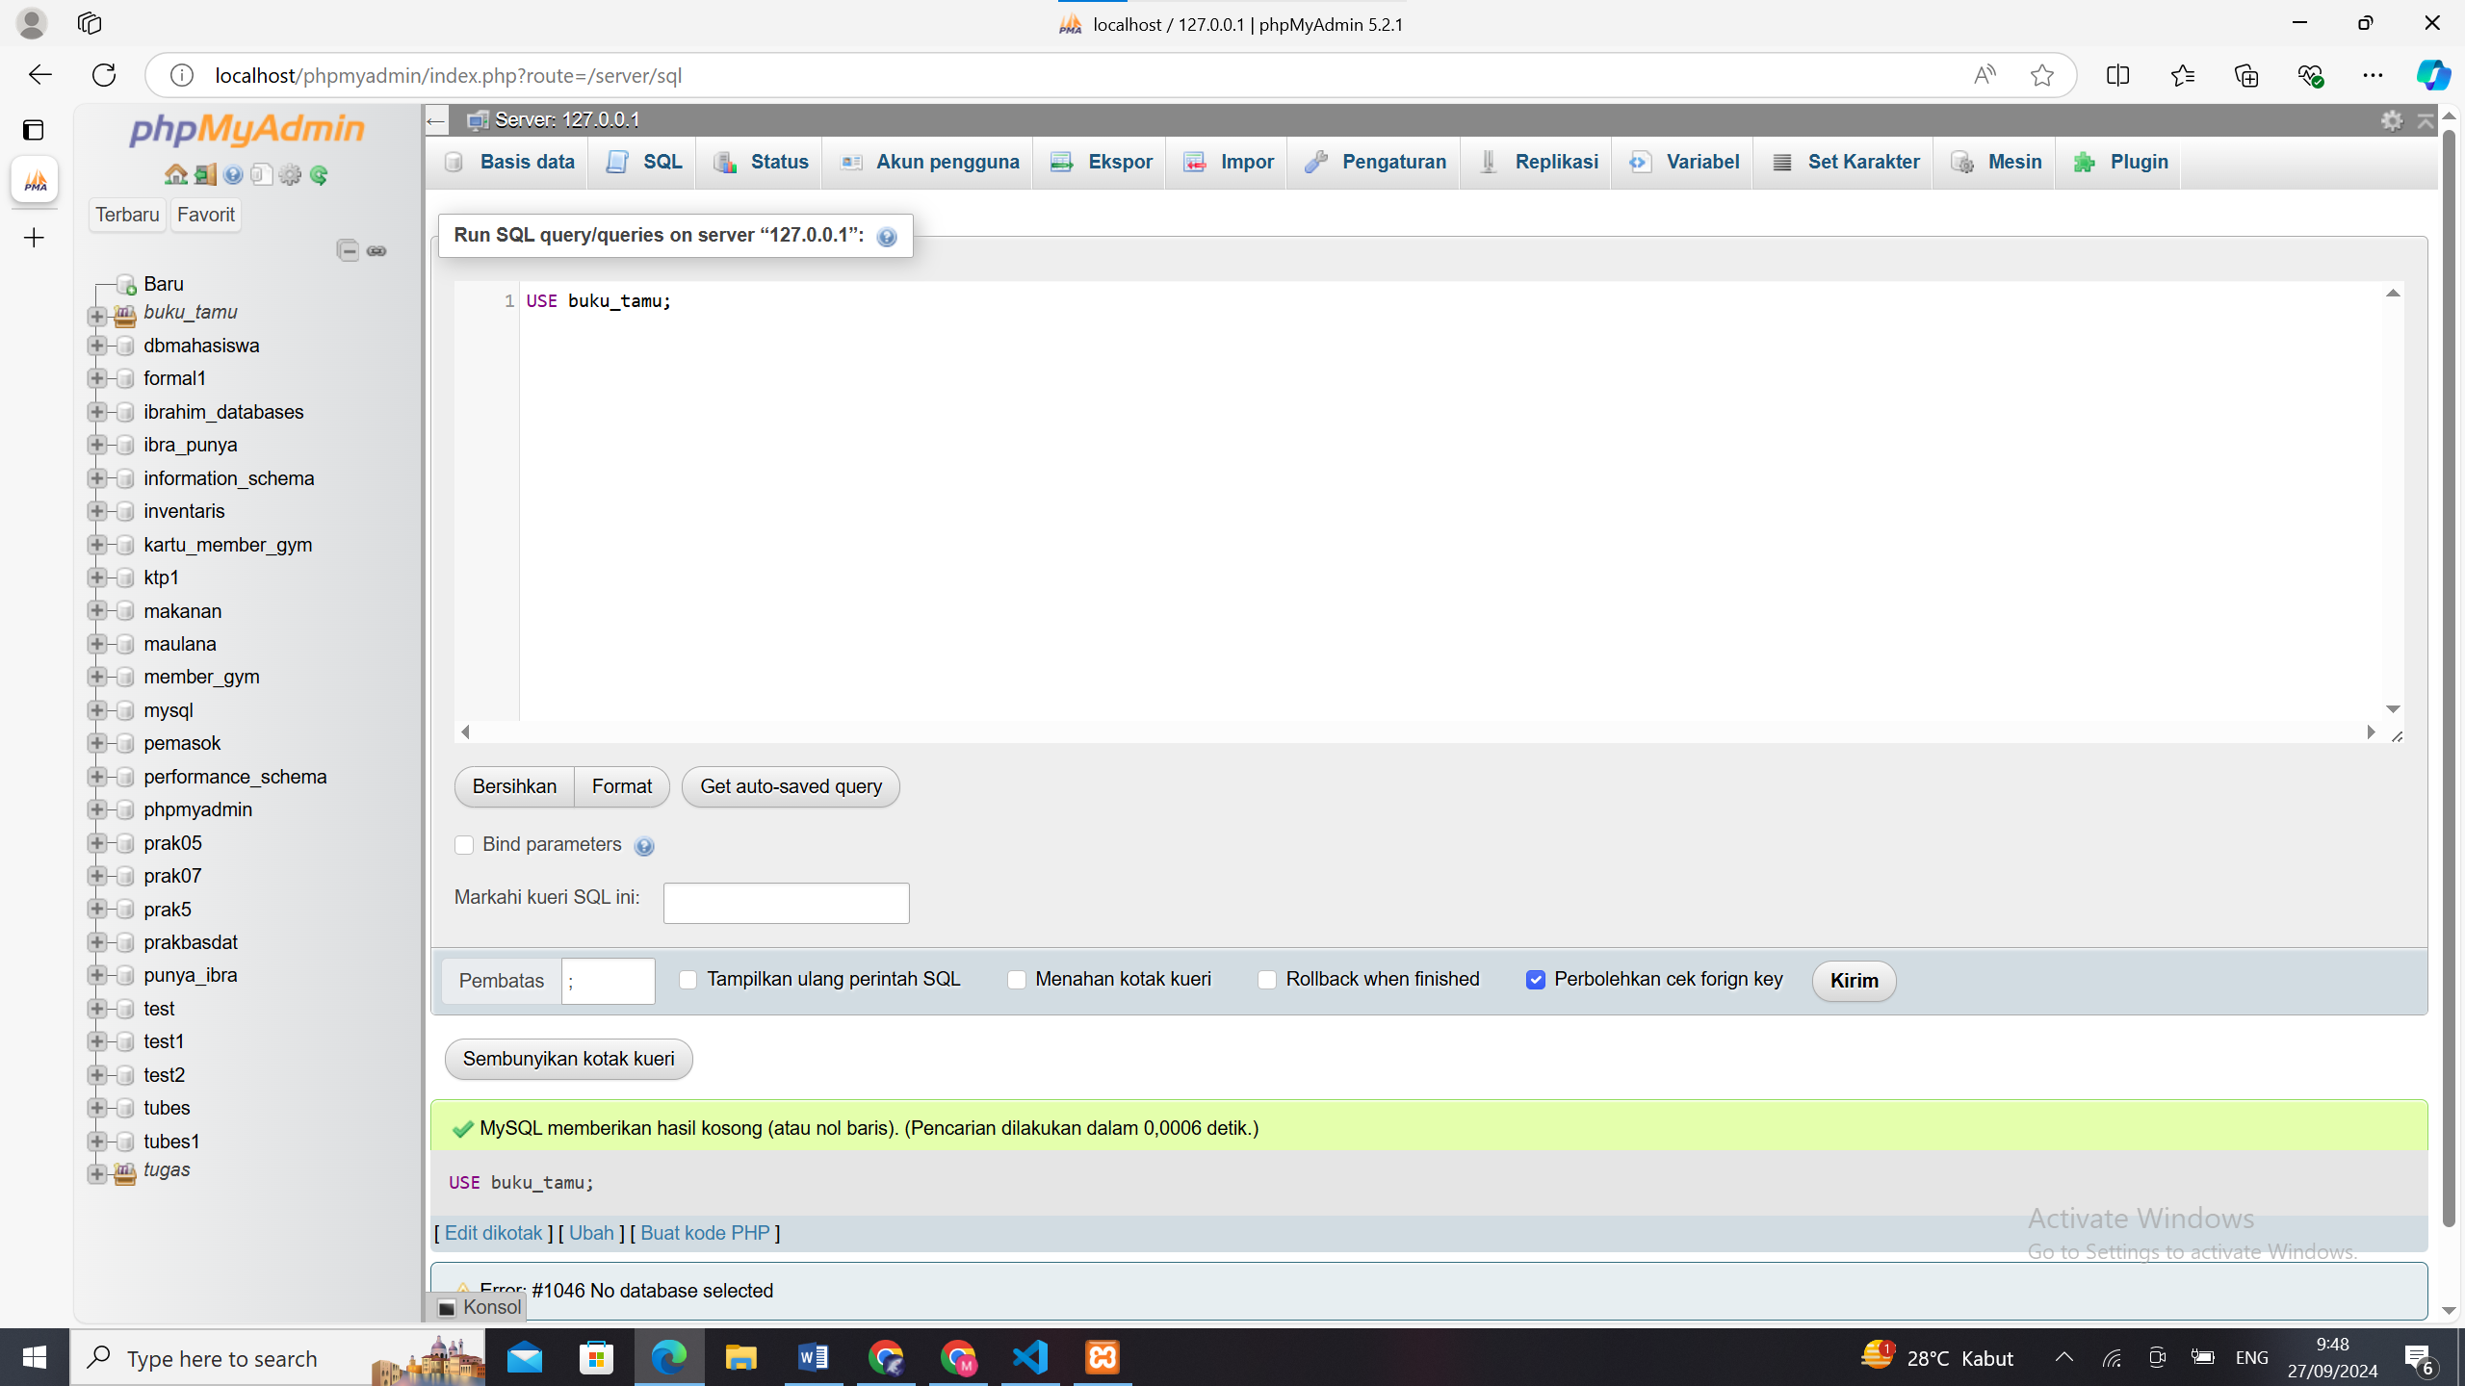

C. CREATE TABLE guests (

id INT AUTO_INCREMENT PRIMARY KEY,

name VARCHAR(100) NOT NULL,

comment TEXT NOT NULL,

created_at TIMESTAMP DEFAULT CURRENT_TIMESTAMP

);

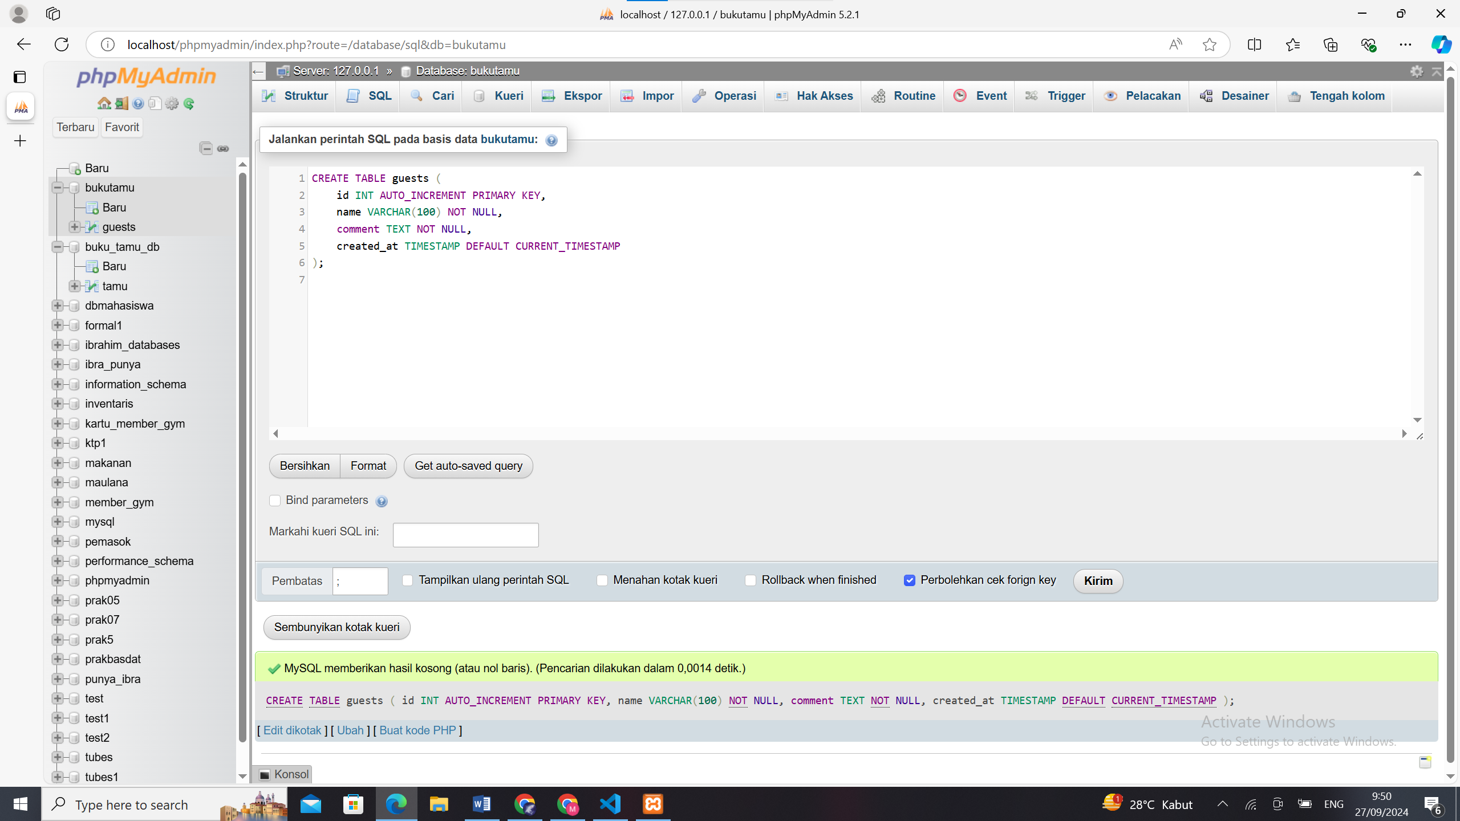

D. CREATE TABLE admins (

id INT AUTO_INCREMENT PRIMARY KEY,

username VARCHAR(50) NOT NULL,

password VARCHAR(255) NOT NULL

);

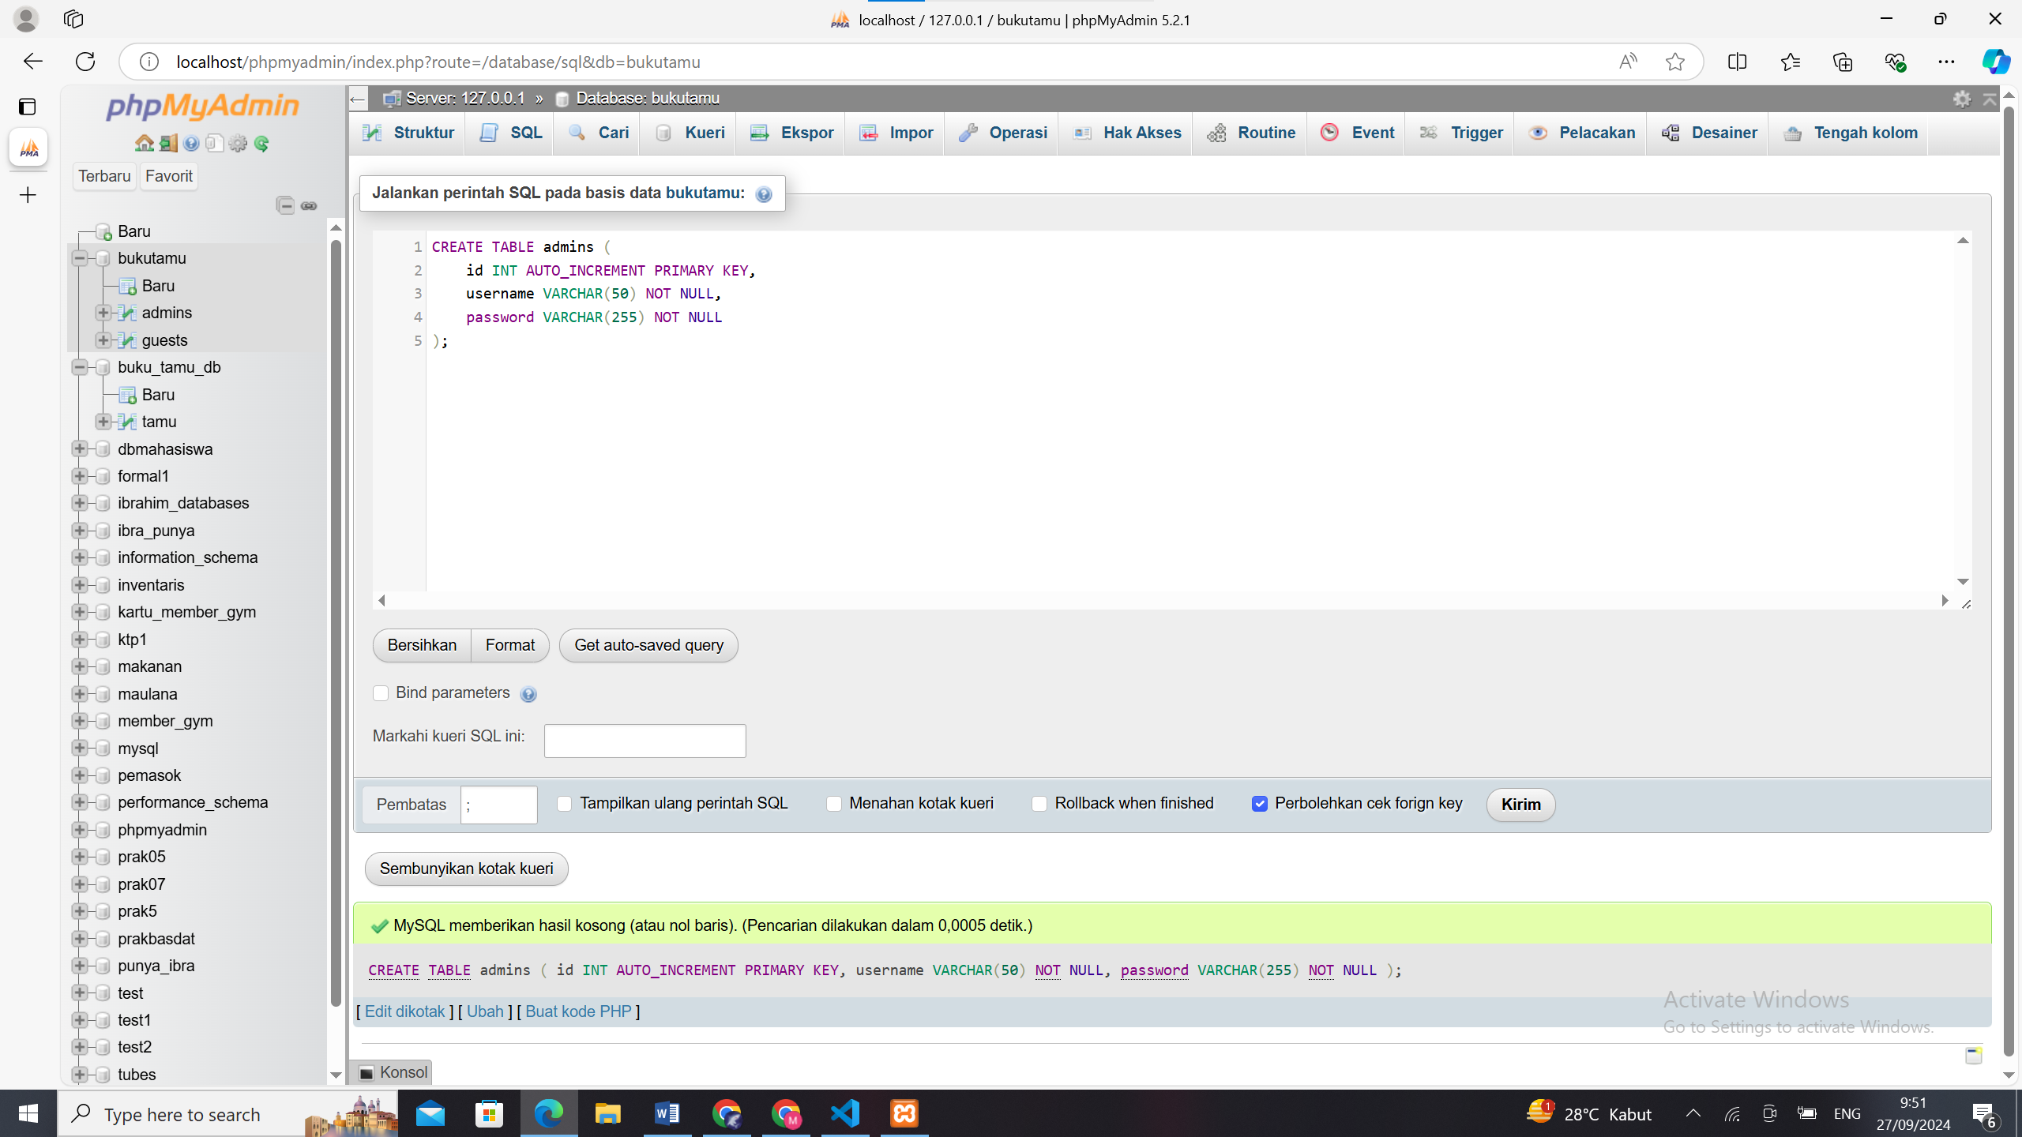

E. INSERT INTO admins (username, password) VALUES ('admin', '$2y$10$e0NRz6iVb6q5VhB8GzJ4JeQc2YJwZgQ8hGgFXc7V3K6i5J9H1K8uK');

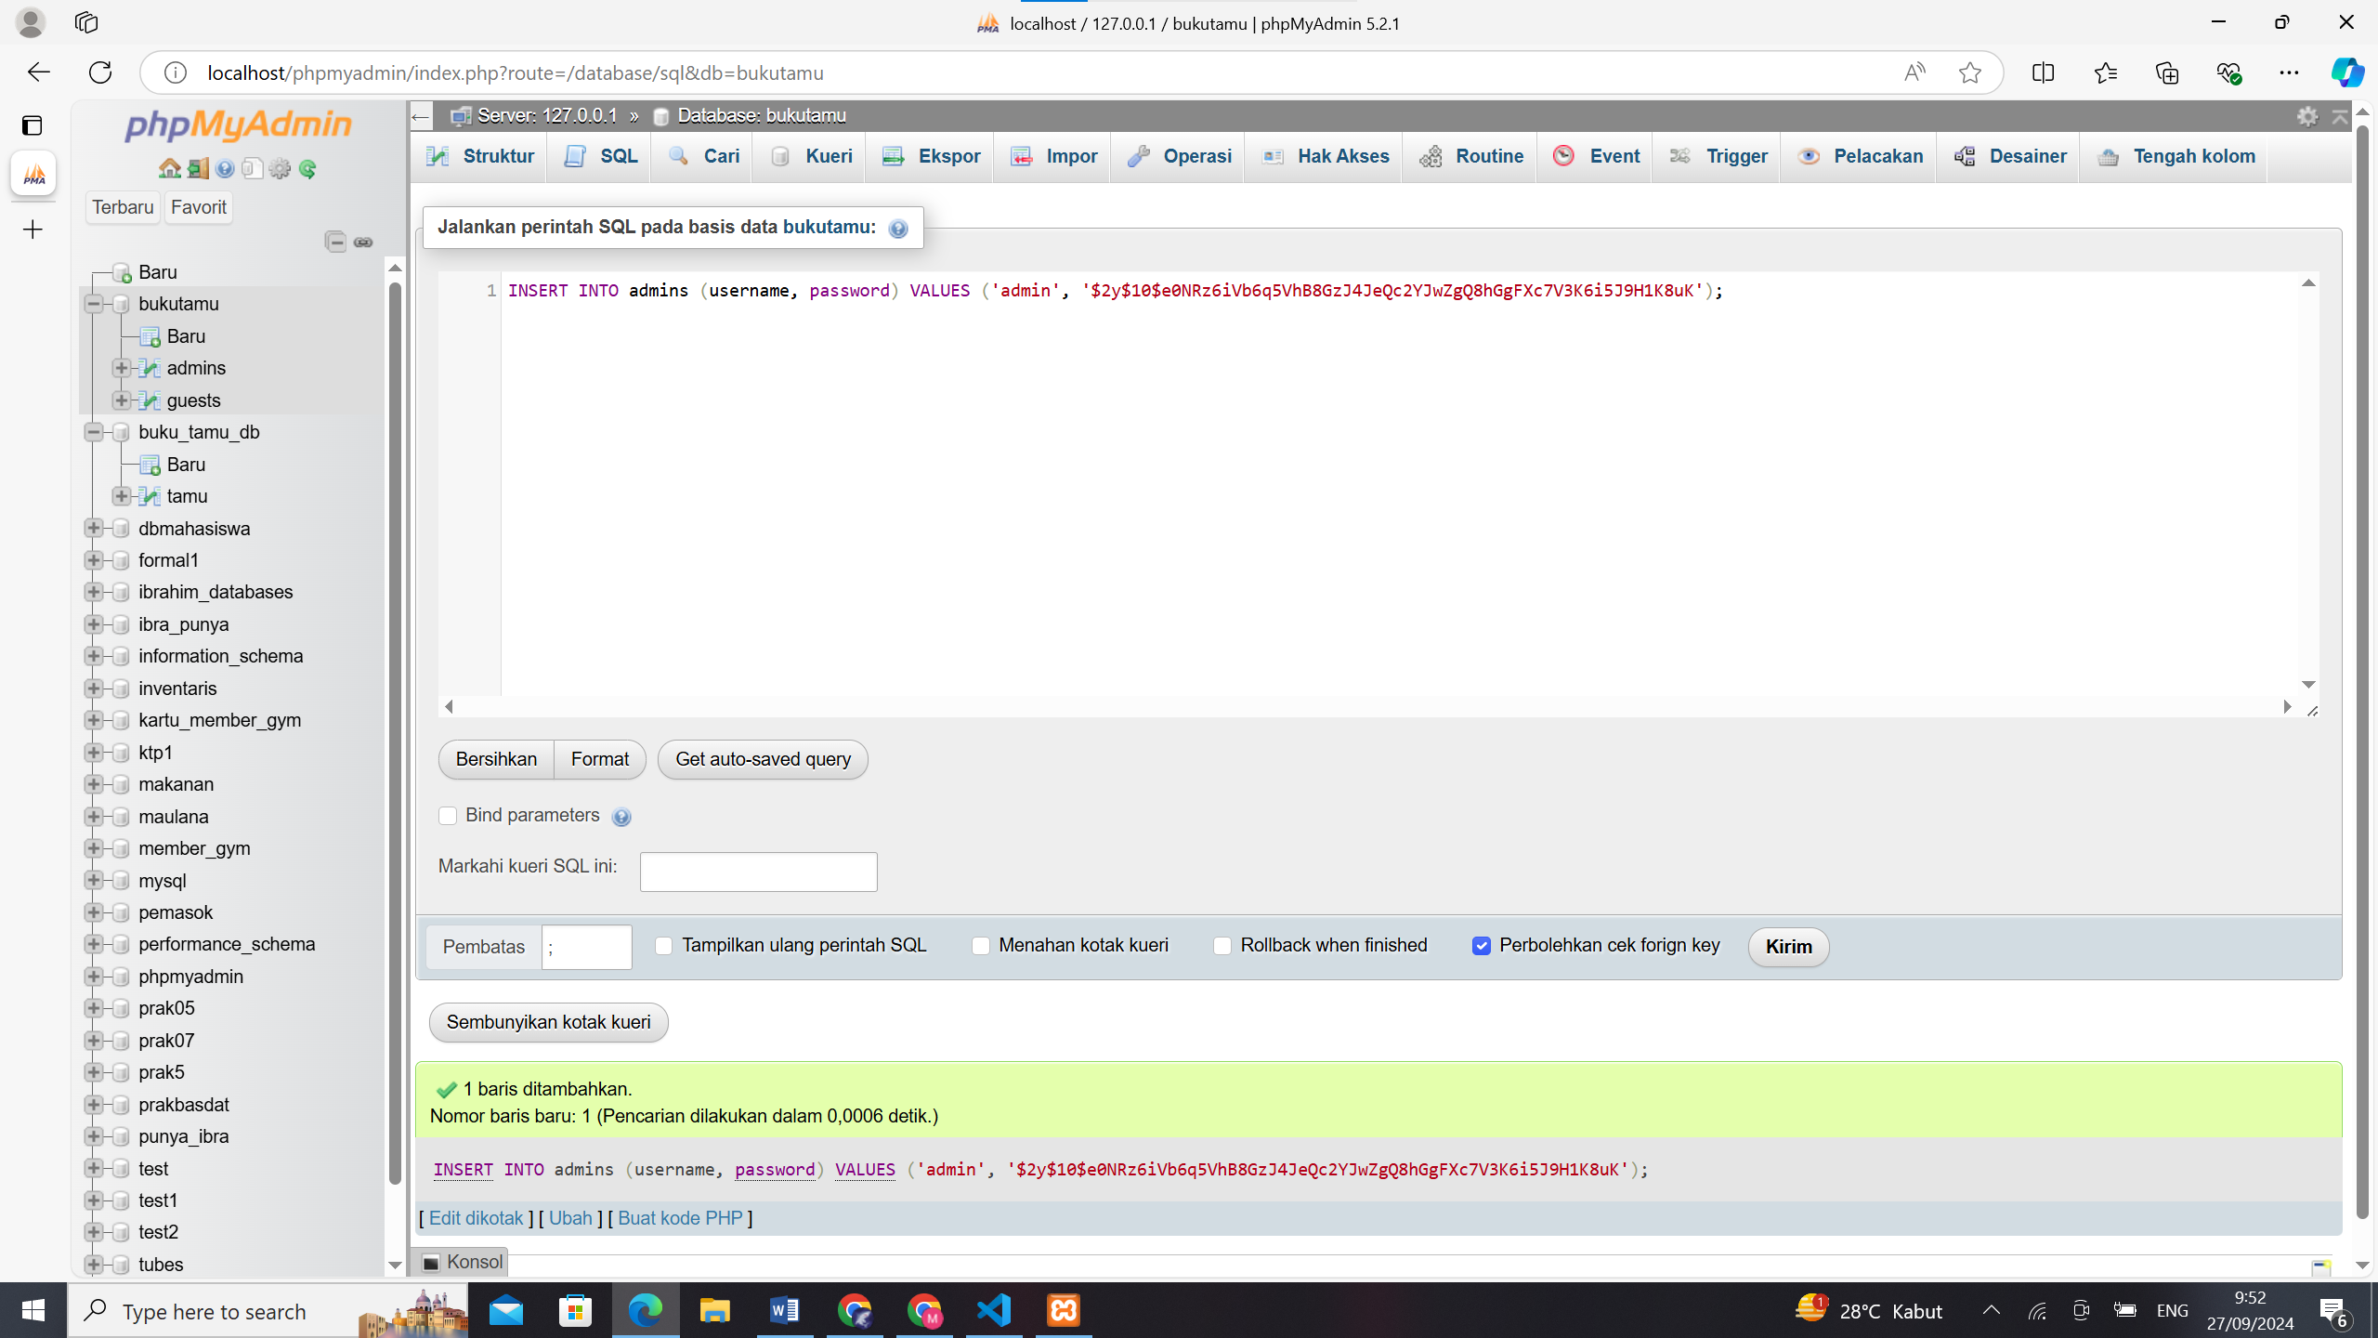

Hasil :

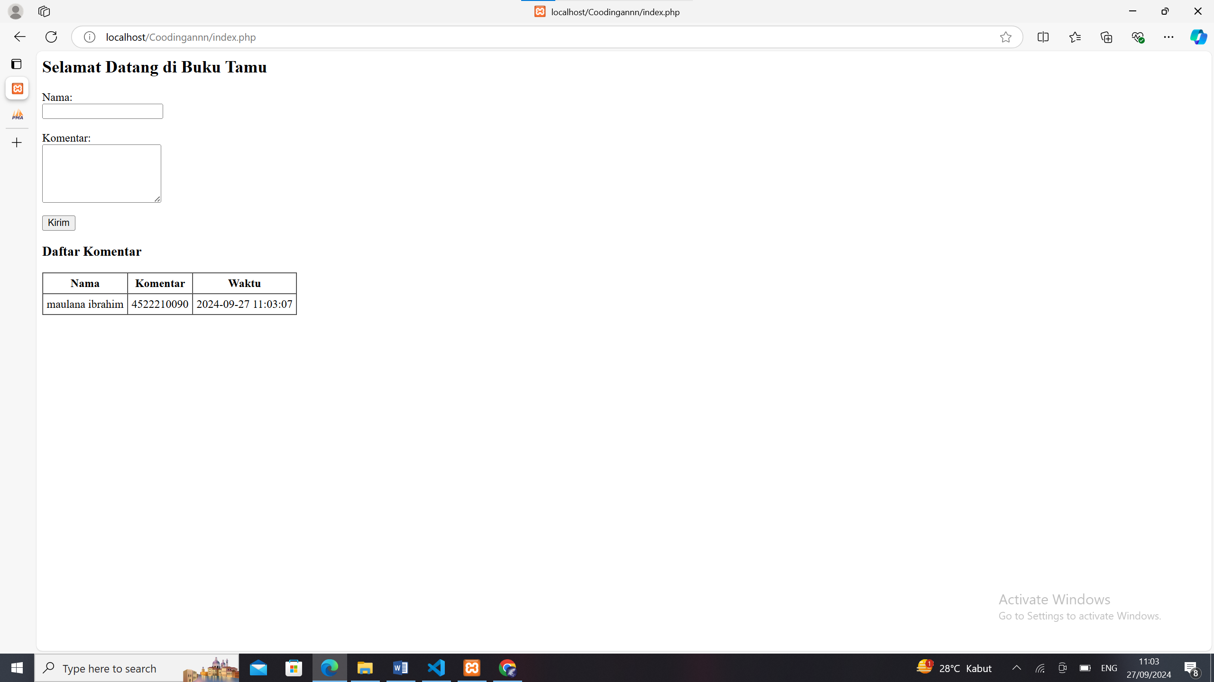

Git hub :

https://github.com/Maulanaibr14/Prak.PBW.git